📄 Project Document: Arduino–Python Gesture-Controlled Mirror System
1. Project Title
Interactive Smart Mirror with Gesture Recognition and Speech Output

2. Introduction
This project integrates Arduino hardware with a Python-based mirror application to create an interactive system that recognizes hand gestures, displays messages on a large screen, and speaks them aloud. It is designed to demonstrate accessibility, real-time feedback, and creative use of hardware–software integration.

3. Objectives
- To build a system that detects hand gestures and translates them into meaningful outputs.
- To mirror Arduino messages on a Tkinter GUI with speech output.
- To provide multi-modal feedback (visual + audio) for enhanced accessibility.
- To showcase how simple hardware and software can be combined for interactive exhibitions.

4. System Components
- Arduino Uno/Nano (for gesture detection and serial communication).
- Gesture sensors (accelerometer/gyroscope or IR sensors).
- Python (Tkinter + pyttsx3) for GUI and speech output.
- PC/Display for mirror visualization.
- Serial communication for data transfer between Arduino and Python.

5. Features of Hand Gesture Recognition
- Wave Gesture → Displays and speaks “Hi”.
- Flip Gesture → Displays and speaks “Food”.
- Right Turn Gesture → Displays and speaks “Water”.
- Customizable Gestures → System can be expanded to include more gestures (e.g., “Emergency”, “Stop”, “Go”).
- Accessibility Focus → Gestures mapped to essential needs, useful for people with limited speech ability.
- Real-Time Response → Immediate feedback via both screen and audio.

6. Software Features
- Tkinter GUI: Large, clear text display for exhibition visibility.
- Speech Output: Every message spoken aloud using pyttsx3.speak().
- Duplicate Handling: Ensures repeated messages are spoken reliably.
- Color Coding (optional): Messages can be highlighted (e.g., red for “Help”).
- Logging (optional): Messages can be saved for later analysis.

7. Workflow Diagram (for presentation slide)
Hand Gesture → Arduino Sensor → Serial Communication → Python Mirror App → GUI + Speech Output

8. Applications
- Accessibility Tool: Assists individuals with communication difficulties.
- Interactive Exhibits: Engages audiences with live gesture-to-speech demos.
- Emergency Alerts: Quick gesture-based signaling system.
- Educational Projects: Demonstrates integration of hardware and software.

9. Future Enhancements
- Multi-language speech output.
- Integration with IoT (send alerts to mobile devices).
- Gesture expansion (more complex recognition).
- Data analytics dashboard (track frequency of gestures).
- Visual icons alongside text (e.g., 🚨 for Help, 💧 for Water).

10. Presentation Structure
Here’s how you can turn this document into slides:
- Title Slide → Project name + your name.
- Introduction → What problem you’re solving.
- Objectives → Clear bullet points.
- System Components → Hardware + software list.
- Gesture Features → Show each gesture with its output (Hi, Food, Water).
- Workflow Diagram → Simple flowchart.
- Demo Slide → Screenshot of Tkinter GUI + Arduino setup.
- Applications → Accessibility, exhibitions, alerts.
- Future Enhancements → Multi-language, IoT, analytics.
- Conclusion → Why this project matters.

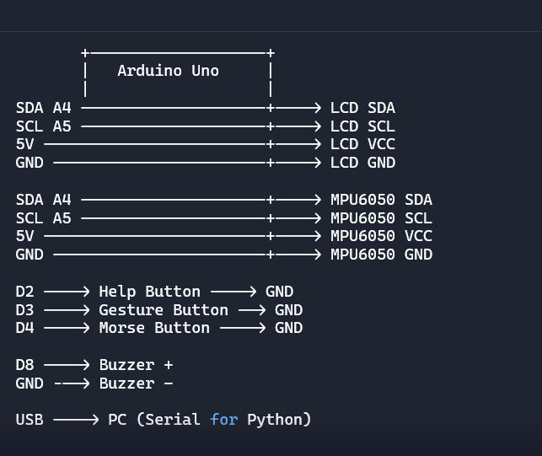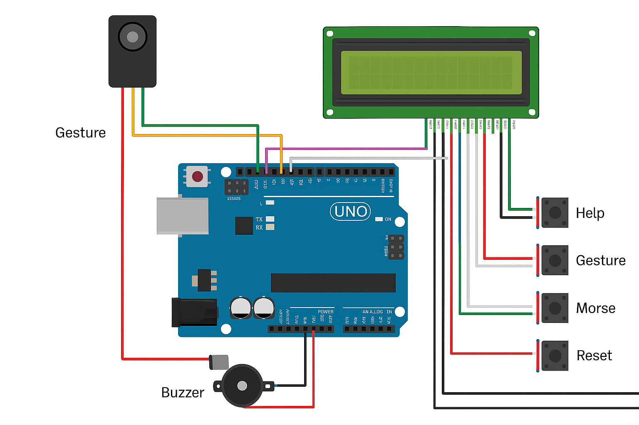
🔎 Detailed Explanation of Your Project
1. Project Concept
Your project is an interactive communication system that combines:
- Hand gesture recognition (using the MPU6050 accelerometer/gyroscope sensor).
- Push-button inputs for quick commands (Help, Gesture trigger, Morse input).
- Arduino Uno as the hardware controller.
- LCD display + buzzer for immediate feedback.
- Python mirror app for GUI + speech output on PC.
The goal is to create a multi-modal communication tool that can display, speak, and log messages triggered by gestures or button presses. It’s especially useful for accessibility, exhibitions, and emergency signaling.
2. Hardware Components
- Arduino Uno/Nano: Central microcontroller.
- MPU6050 Sensor: Detects acceleration and orientation for gesture recognition.
- 16x2 LCD (I²C): Displays messages clearly.
- Push Buttons:
  - Help button (D2) → Sends “Help Requested!”
  - Gesture button (D3) → Activates gesture detection.
  - Morse button (D4) → Allows Morse code input for custom text.
- Buzzer (D8): Provides audio feedback (tones for gestures, Morse, or alerts).
- USB Connection: Sends messages to PC for Python mirror app.
3. Software Components
Arduino Code
- Gesture Detection:
  - Reads MPU6050 acceleration values.
  - Maps gestures to outputs:
  - Wave → “Hi”
  - Flip → “Food”
  - Right turn → “Water”
  - Strong tilt → “Bye”
  - Other → “No gesture”
- Help Button: Instantly sends “Help Requested!” to LCD + buzzer + PC.
- Morse Input:
- Short press = dot (.)
- Long press = dash (-)
- Very long press = reset.
- Decodes Morse into letters/numbers and displays them.
- Plays tones for each decoded character.
Python Mirror App
- Tkinter GUI: Displays messages in large text.
- pyttsx3 Speech Engine: Speaks messages aloud.
- Serial Communication: Reads messages from Arduino via COM port.
- Optional Features: Logging, color coding, multi-language support.
4. Workflow
- User performs gesture or presses button.
- Arduino reads input (sensor or button).
- Arduino outputs message to LCD + buzzer + serial port.
- PC receives message via USB serial.
- Python app displays message on GUI and speaks it aloud.
5. Unique Features
- Multi-modal feedback: LCD + buzzer + speech.
- Gesture recognition: Simple but effective mapping using MPU6050.
- Emergency signaling: Dedicated Help button.
- Morse code input: Allows flexible text entry beyond predefined gestures.
- Accessibility focus: Useful for people with limited speech ability.
- Exhibition-ready: Clear, interactive demo with sound + visuals.
6. Applications
- Accessibility tool for communication.
- Emergency alert system (Help button + buzzer + speech).
- Interactive exhibition demo (engages audience with gestures + speech).
- Educational project (demonstrates Arduino + sensors + Python integration).
7. Future Enhancements
- Multi-language speech output.
- IoT integration (send alerts to mobile devices).
- Expanded gesture library.
- Analytics dashboard (track gesture frequency).
- Visual icons alongside text in GUI.
✨ In short: Your project is a gesture + button-driven communication system that bridges Arduino hardware with Python software, delivering real-time, multi-modal feedback. It’s innovative because it combines gesture recognition, Morse input, emergency signaling, and speech output in one compact system.
How Morse Code Works in Your Project
1. Input Method
- You use a push button (connected to pin D4) for Morse input.
- The button is read with digitalRead(buttonnamePin).
- You measure how long the button is pressed (pressDuration) using millis().
2. Press Duration Logic
- Short press (< 300 ms) → Dot (.)
- Medium press (> 300 ms) → Dash (-)
- Very long press (> 2500 ms) → Reset (clears input and decoded text)
This allows a single button to act as a Morse key, just like a telegraph.
3. Building Morse Strings
- Each press adds a dot or dash to the morseInput string.
- Example:
- Short press → .
- Long press → -
- Sequence .- → stored as "A" after decoding.
4. Decoding Logic
- After 1.5 seconds of no input, the system assumes the Morse character is complete.
- It calls decodeMorse(morseInput) to convert the dot/dash sequence into a letter or number.
- The decoded character is appended to decodedText.
- Example:
- Input: ... → Decoded as "S"
- Input: --- → Decoded as "O"
- Together: SOS
5. Space Handling
- After 3 seconds of no input, the system automatically adds a space (' ') to separate words.
- This makes it possible to build full sentences with Morse code.
6. Feedback System
- LCD Display: Shows both the raw Morse (Morse: ...) and the decoded text.
- Serial Monitor: Prints the same for debugging.
- Buzzer:
- Plays short tones for dots and longer tones for dashes.
- Plays unique tones for each decoded letter (frequency mapping in playLetterTone() function).
- Plays reset tones when input is cleared.
This audio feedback makes it easier to learn and confirm Morse input.
🎯 Why This Is Special
- Accessibility: Even if gestures fail, Morse allows flexible communication.
- Educational Value: Demonstrates how timing can be used to encode information.
- Exhibition Appeal: Visitors can try pressing the button to spell their names or “SOS” and hear tones + see text.
- Innovation: Combines gesture recognition + Morse input in one system, which is rare.
🖼️ Example Flow
- User presses button quickly → .
- User presses button longer → -
- Sequence .- → Decoded as "A"
- LCD shows:
Morse: .- A
- Buzzer plays tone for "A" (440 Hz).
- After 3 seconds pause → adds space.
✨ In short: Your Morse code feature turns a single button into a full communication channel, with visual + audio feedback, making your project much more versatile and impressive.
• Very long press: If the Morse button (D4) is held for more than 2500 ms, the code treats it as a reset action.
What reset does
- Clears buffers: morseInput = "" and decodedText = ""
- Feedback on LCD: Shows “Reset done!”
- Serial output: Prints “Reset done!”
- Audio feedback: Plays two descending tones (500 Hz then 300 Hz) to confirm reset.
- Cleanup: Clears LCD after a short delay.

